APPLICATION BUILDING

|  |  |
| --- | --- |
| Date | 19 November 2022 |
| Team ID | PNT2022TMID41657 |
| Project Name | AI-Powered Nutrition Analyzer for Fitness Enthusiasts |

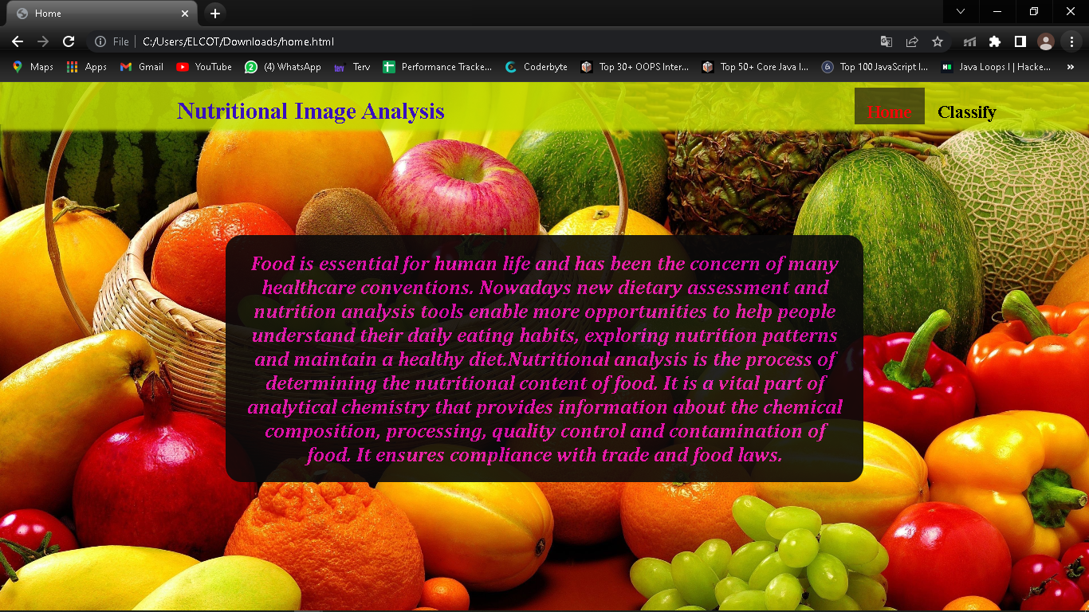

PNT2022TMID41641

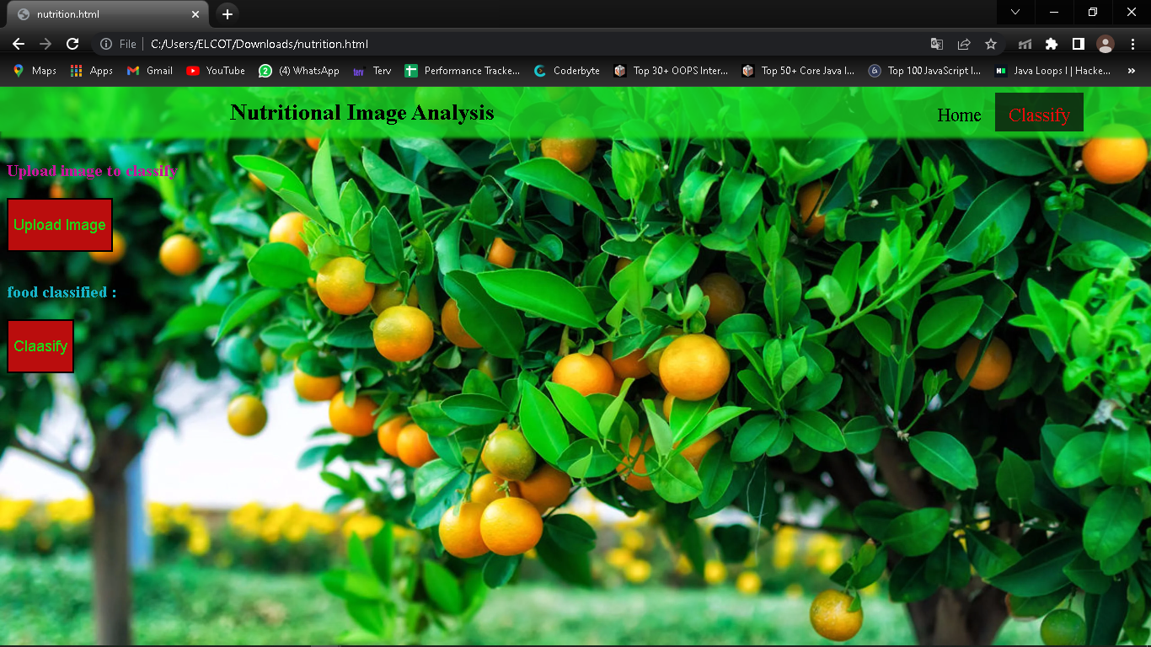

PNT2022TMID4164

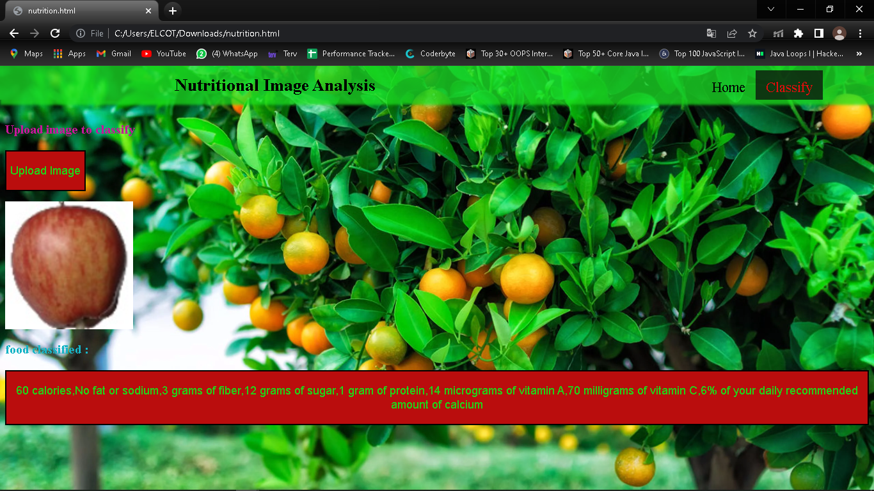

PNT2022TMID41641